CYRUS BRADY McCUNE

( May 5, 1850 – October 20, 1920 )

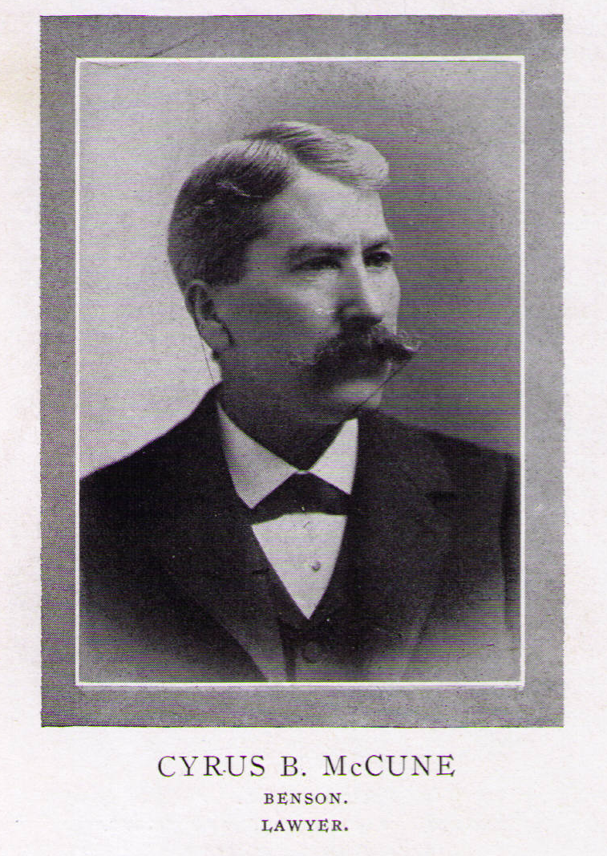
(1915)

Cyrus McCune arrived in Benson, the seat of Swift County, in 1884 with an interest in law and newspaper publishing. A member of the bar of Indiana, he entered into a partnership with Walter A. Foland, a graduate of the Indiana University Law School. About the same time, they started the Benson Times newspaper. For the next several decades they practiced law and published the Times. The firm dissolved when Foland became clerk of the district court.

McCune died on October 20, 1920, at age seventy. The next day, the Swift County Monitor reported his passing on its front page:

C. B. McCune Dead─
Heart Trouble Cause
__________

C. B. McCune, a resident of Benson since 1884 and one of its most distinguished citizens, died at his home here yesterday morning at four o’clock at the age of 70 years. Heart trouble was the cause of his death.

The past two months Mr. McCune’s health failed rapidly, and the ten days ago it took a serious turn. A week ago Saturday he returned from Minneapolis where he had been in consultation with specialists studying his case. Hugh and Guy McCune, sons of the deceased, were called home the latter part of last week to see their father but both had left when Mr. McCune died.

Cyrus Brady McCune was born in Cumberland county, Pennsylvania, on May 5, 1850, of Revolutionary stock. He attended school in the east and graduated from Princeton university at Princeton, New Jersey. He taught school at Montezuma, Ind., and later read and practiced law at Terre Haute. Ind.

In 1884 Mr. McCune came to Benson, and in the following year went into partnership with W. A. Foland, present clerk of court in the practice of law and the publication of the Benson Times, in 1912 transferred to Holloway and continued as the Holloway Herald. He was elected county attorney in the 90’s and served two terms.

During his residence here Mr. McCune has been a member of the Congregational church, and was affiliated with the Knights of Pythias and the A. O. U., and has always been a leader in public and political activity. The deceased is survived by his wife, two sons, Hugh practicing law at Fairmont, and Guy, attending the state university, and one brother, J. H. McCune, who has lived with his brother in this city the past 30 years.

At its annual convention in 1921, the Minnesota State Bar Association presented the following memorial to him:

Cyrus Brady McCune was born in Cumberland County, Pennsylvania May 5th, 1850, of Revolutionary ancestry. He was educated in the public schools and at Princeton University, from which institution he was graduated, afterward teaching school for a time. He read law in Terre Haute, Indiana and practiced for some time in that city.

In 1884 he removed to Benson, Minnesota, and entered into partnership in the practice of law and the publication of the Benson Times newspaper with W. A Foland, now Clerk of the District Court of this county, which con-nection remained unbroken until the appointment of Mr. Foland to the office of Clerk of Court some nine years ago.

In 1896 he was elected to the office of County Attorney and served two terms.

He was married to Miss May Foland by whom he had three children, two of whom with his wife survive him.

Mr. McCune was a plain man, well grounded in the law, honest and conscientious both as a lawyer and a man. A man of strong character and forceful personality, he was firm and fearless in the discharge of his duties both public and private.

As County Attorney, his record was an excellent one, and his entire career during his residence among us was marked by a keen love of justice and a strict adherence to its principles.

Politically a strong partisan and a forceful speaker in public debate, he was always fair and endeavored to make his case clear by a plain presentation of facts.

He was intensely American and at all times, and especially during the world war did much, both by word and deed, to deepen the spirit of loyalty in his community and was a staunch supporter of the Government in its great crisis.

In his home community he took an active interest in civic affairs and was a wise and valued counsellor in all that pertained to the development and progress of the city and county of his residence.

His character both in public and private life is unsullied and his death is a profound loss to the community. ■

Swift County Monitor, Thursday, October 21, 1920, at 1.
Proceedings, Minnesota State Bar Association 228-29 (1921). The photograph on the first page is from Men of Minnesota 208 (1915). »» M «« Posted MLHP: May 8, 2013; Photograph added, May 13, 2015.

